**MINI PROJECT ON ATM MANAGEMENT SYSTEM**

**INSTITUTE NAME : CDAC TVM**

**DONE BY : Chaitanya Patil**

**Description :**

**In this project i create a small atm management system , which perform various operations like**

1. **Login In System**

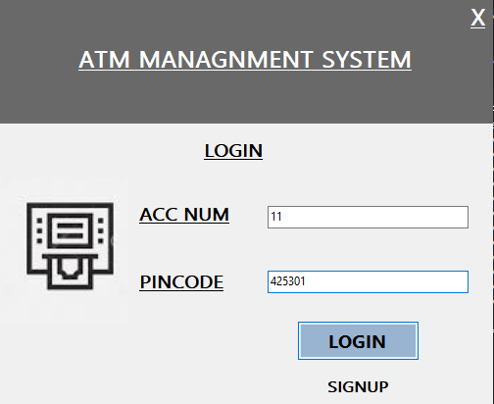

1. **Home Page :**

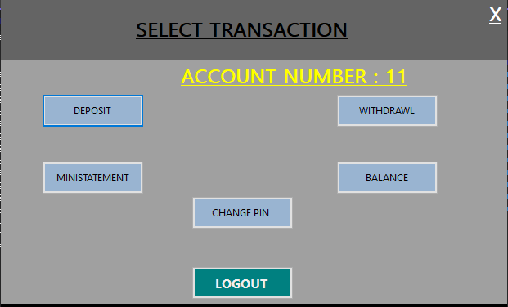

1. **Deposit money**

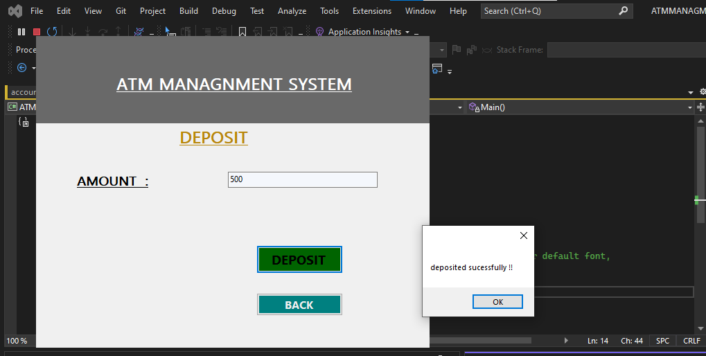

**4.Withdral Money**

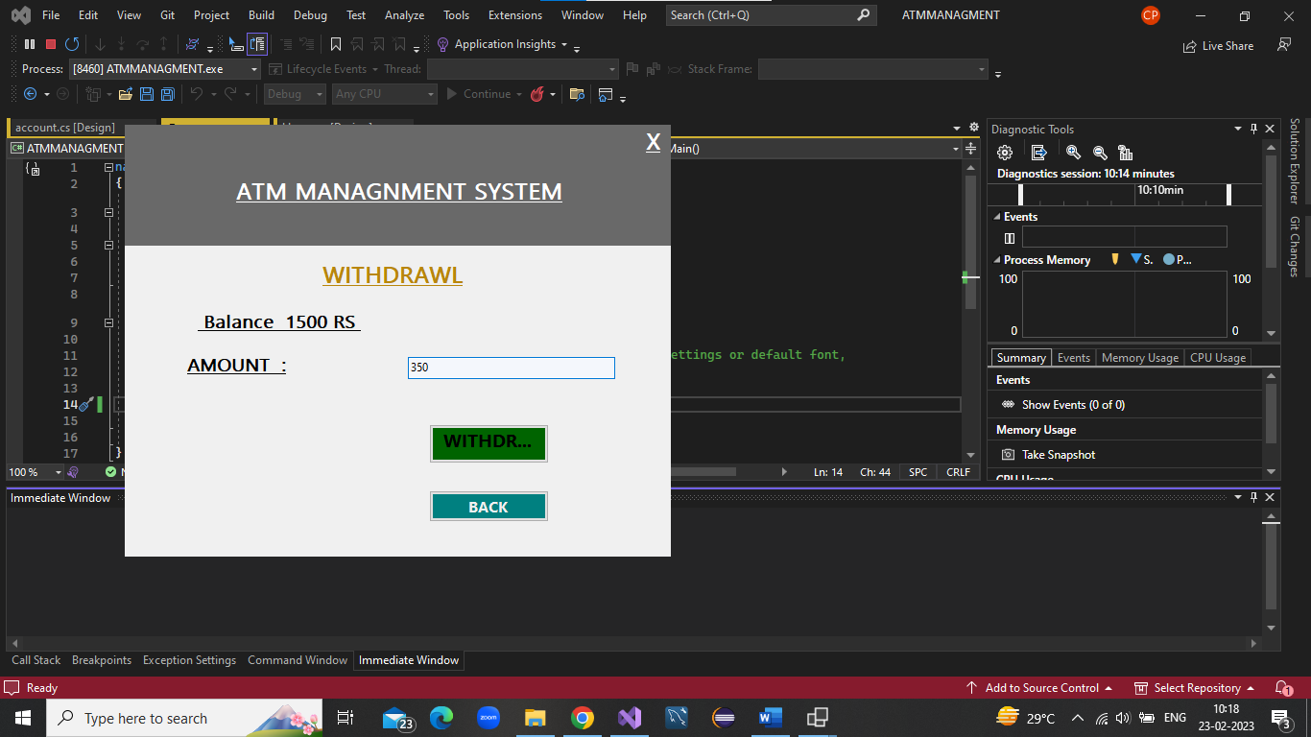

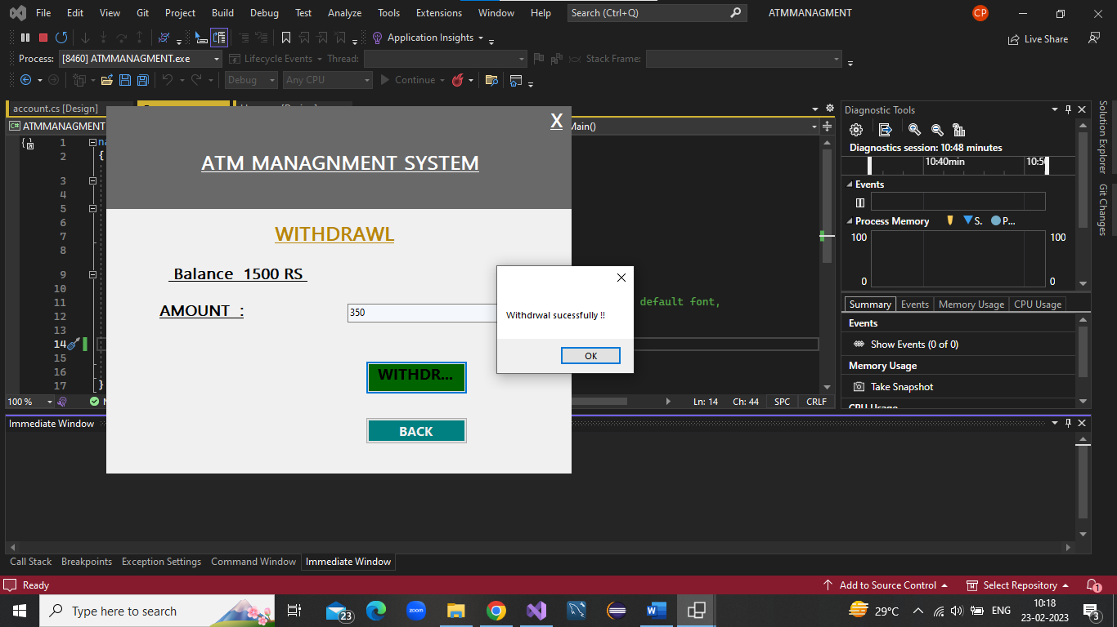

**5.Balance details**

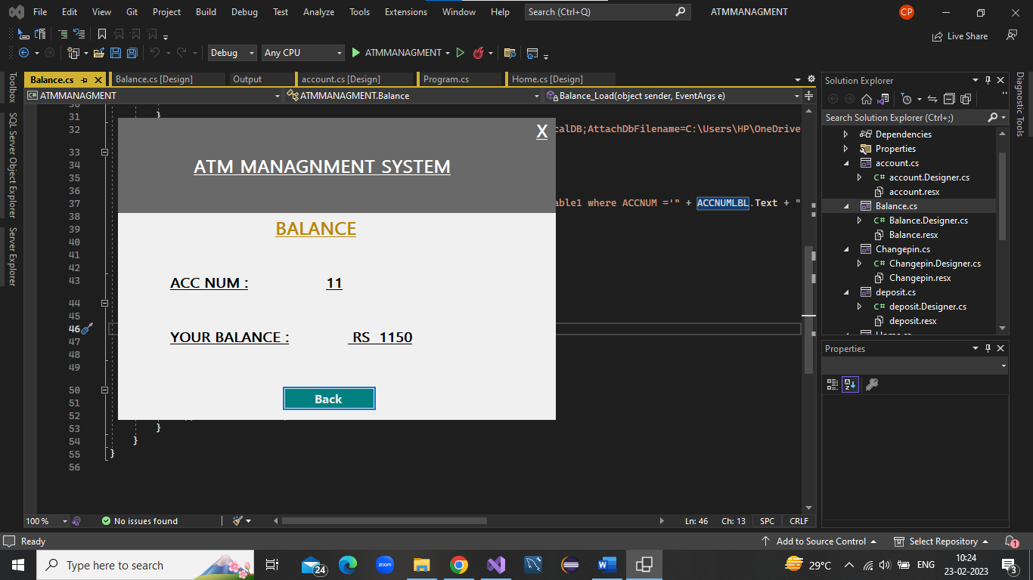



**THIS IS EXIT ,BACK BUTTONS**



**6. Change The Login Pin**

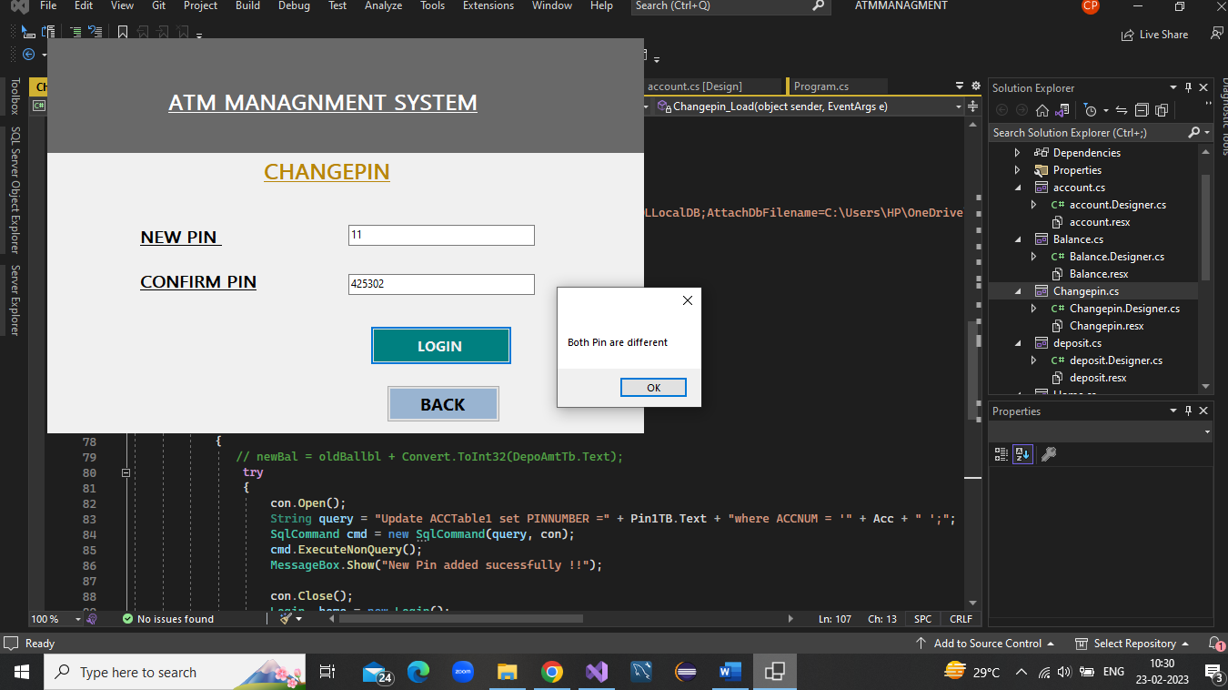

**Errors if both are different**

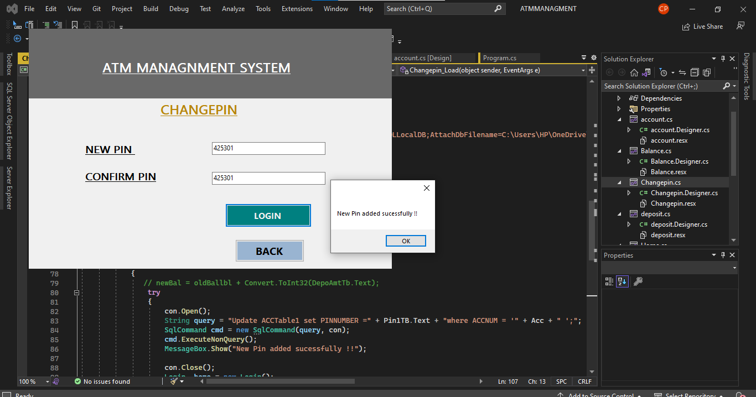

**Both must be same new and confirm**

**7 .Adding new user**

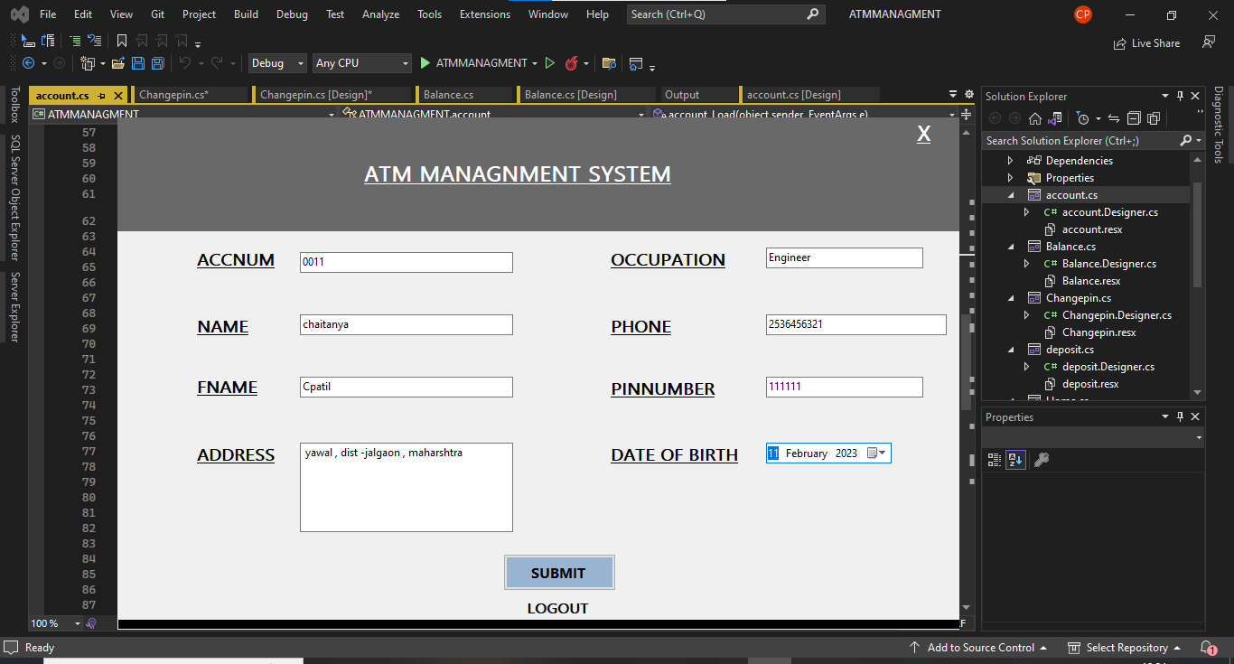

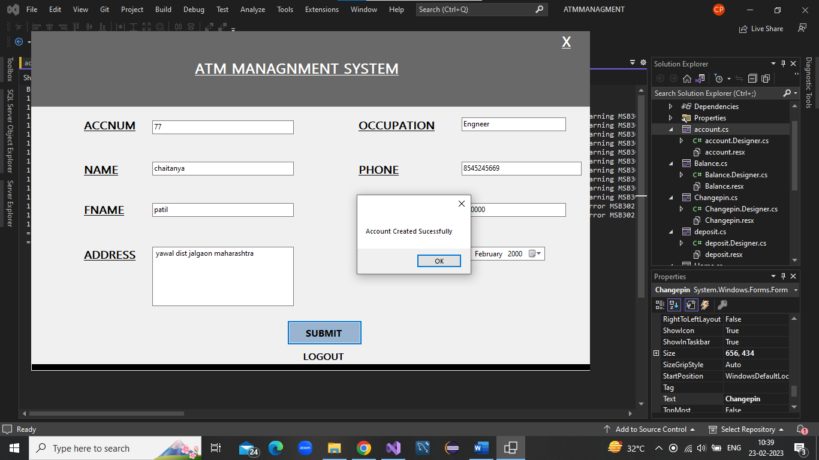 **Error for adding same Account number**

